LG Split Air Conditioner
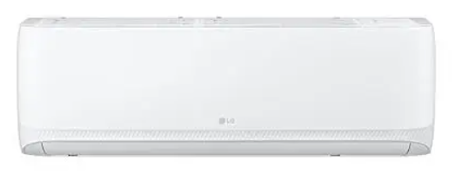
Rs.110,177
LG split air conditioner T18ZCA gives fast cooling, smart diagnosis, auto swing, and anti-corrosive protection in a 1.5-ton wall-mounted system.

Specifications
- Model: T18ZCA
- Capacity: 1.5 Ton
- Controls: 24-hour timer
- Protection: Anti-corrosive coating

Key Features
- Fast cooling
- Auto swing
- Smart diagnosis
- Auto restart

